Theater review: 'The Matchmaker' at Victory Theatre Center
October 2, 2009 | 1:30 pm
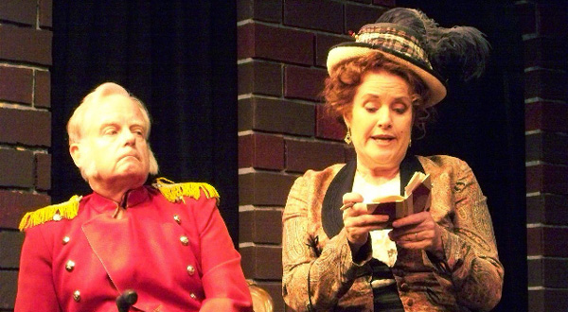
Thornton Wilder, notable for winning Pulitzers for a novel and two plays, was a theatrical experimenter whose most arguably conventional work is “The Matchmaker,” a sweetly rendered Valentine to 1890s New York.
Of course, Wilder’s gentle comedy about the inimitable Dolly Gallagher Levi, an Irish-born yenta who eases the path of various romances while angling to hook her own rich husband, later became source material for the massive musical hit, “Hello, Dolly!” But whereas the musical remains an unapologetic star vehicle for the reigning divas of the day, the play is far more egalitarian, a rich aggregation of innocents and eccentrics, many of whom break the fourth wall to directly address the audience.
Dave Florek’s staging for the Interact Theatre Company at the Victory Theatre Center boldly emphasizes the play’s sweetness while neatly avoiding sentimental stickiness. Curiously, Florek gives the plot’s farcical elements somewhat short shrift. After all, when characters don drag and hide under tables, subtlety is not the best option.
But that’s a minor flaw in an otherwise lively production that showcases the talents of both seasoned stage veterans and less polished newcomers. Refreshingly free of the diva-esque, Amanda Carlin’s delightful Dolly has just the right touch of cheerful coarseness. As wealthy curmudgeon Horace Vandergelder, James Gleason mitigates his character’s irascibility with the faintest hint of a twinkle. And as boozy jack-of-all-trades Malachi Stack, James Greene is matter-of-factly marvelous. His wryly hilarious “one vice at a time” monologue is the evening’s highlight.
-- F. Kathleen Foley
“The Matchmaker,” Victory Theatre Center, 3326 W. Victory Blvd., Burbank. 8 p.m. Fridays-Saturdays, 4 p.m. Sundays. Ends Oct. 18. $25. (818) 765-8732. Running time: 2 hours, 10 minutes.
Photo: James Gleason and Amanda Carlin in "The Matchmaker" at Victory Theatre Center. Credit: Amanda Troop

